**Opt-Sim**

**In Mozilla Science Lab**

**OPTICAL MIRRORS EXPERIMENT SIMULATION**

**G.Kalaiyarasi**

**S.Jeyarani**

**S.Sutharsika**

**J.Jesitha**

**Table of Contents**

**1. Scope and Purpose of the Project**

**2. Process overview of the project**

**3. How you can use**

**3.1 Introduction the structure of Interface**

**3.2 How to insert mirrors and object to the experimental area**

**3.3 How to adjust mirrors and Object**

**3.4 How to remove mirrors and Reset**

**4. Screen Shots and explanation**

**5. Future Works**

1. **Scope and Purpose of the Project**

We are developing a project for optical mirrors experiment simulation. Via this project, we expect pupils can learn about optical physics in a friendly, interactive environment. It will be like getting image and ray diagram for object's position from mirrors like convex, concave and mirror. We made that dynamic like we can drag the object towards or backward from lenses. We used Html5, kineticjs (JavaScript library) and CSS to develop this. We are contributing this project for [Mozilla Science](http://mozillascience.org/) [Lab.](http://mozillascience.org/)

1. **Process Overview project**

In this experiment, there are three categories with convex, concave, mirror. Each categories works five different cases such as

* Case 1: the object is located beyond the center of mirror (C/2F)
* Case 2: the object is located at the center of mirror (C/2F)
* Case 3: the object is located between the center of mirror (C/2F) and the focal point (F/2F)
* Case 4: the object is located at the focal point (F)
* Case 5: the object is located in front of the focal point (F)

1. **How you can use**

**3.1 Introduction the Structure of Interface**

* This application consist Experimental area, Mirrors Toolbar, Objects Toolbar and Help button. We can perform simulation in this Experimental Area.
* In the mirror toolbar types of mirrors are shown such as Convex, Concave, and Plane mirror.
* In the object toolbar there are three objects, they are Arrow, Triangle and Polygon.
* To get Help, there is an icon with question mark.

**3.2 How to insert mirrors and object to the experimental area**

There is a horizontal line placed in the experimental area and that is center axis of mirrors. You can drag and drop mirrors from mirrors toolbar. You can replace these mirrors by drag and drop the wanted mirrors over or near to the existing mirrors. After you added mirrors the ‘F’ and ‘C/2F’ will be added in both side of the mirrors.

In objects tool bar three objects are placed. You can select one of these objects by clicking the corresponding icon to get the object in experimental area. You can add only one object at a time. if you click on the other object, the existing object will be replaced by new object

**3.3 How to adjust Mirrors and Object**

Mirrors will be placed in center of the experimental area and they drag only in horizontal axis. You can drag the mirrors within the range of between object and end of the experimental area.

Object can be move between starting of the experimental area and mirror’s position. So, you can change the distance from the mirrors. And you can identify the object’s position such as beyond C/2F, between C/2F and F, within F by looking at the F,2F symbols.

While you drag mirrors or object you can see the ray diagram and the image generated by mirrors for corresponding object will appear dynamically

**3.4 How to remove Mirrors**

To remove a mirror from the experimental area just double click on the mirrors.

1. **Screen Shots and explanation**

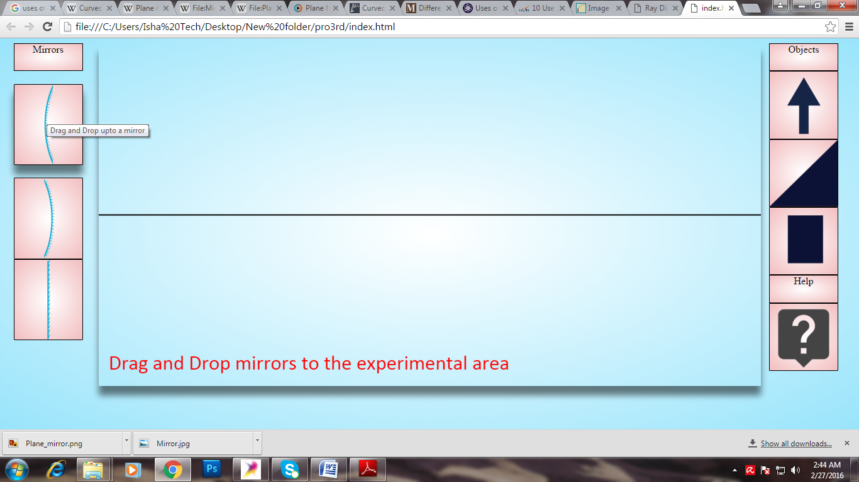

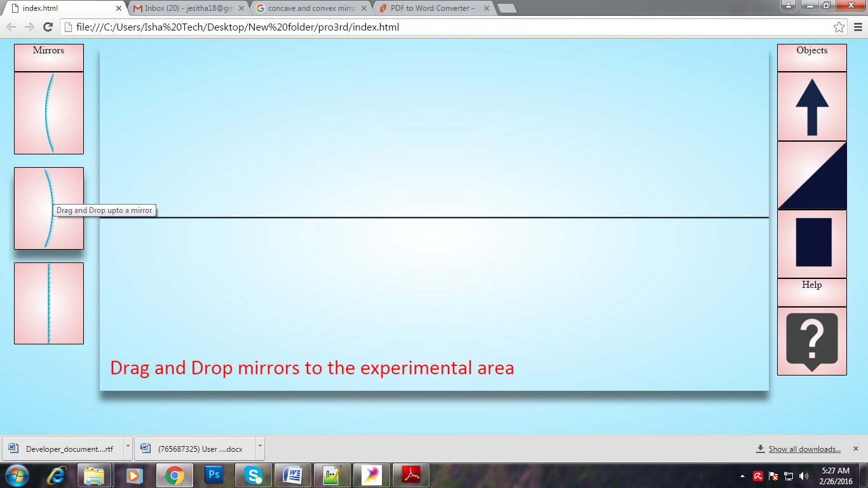

Drag any mirror from mirror’s toolbar

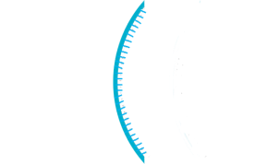

Drop the mirror in the experimental area

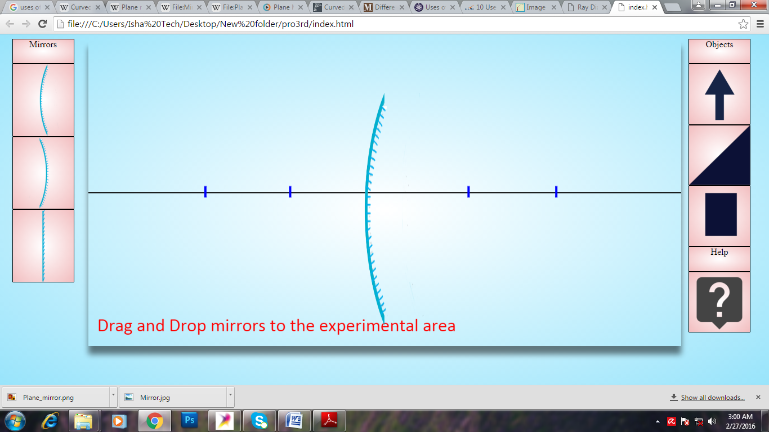

Mirror will appear in the experimental area

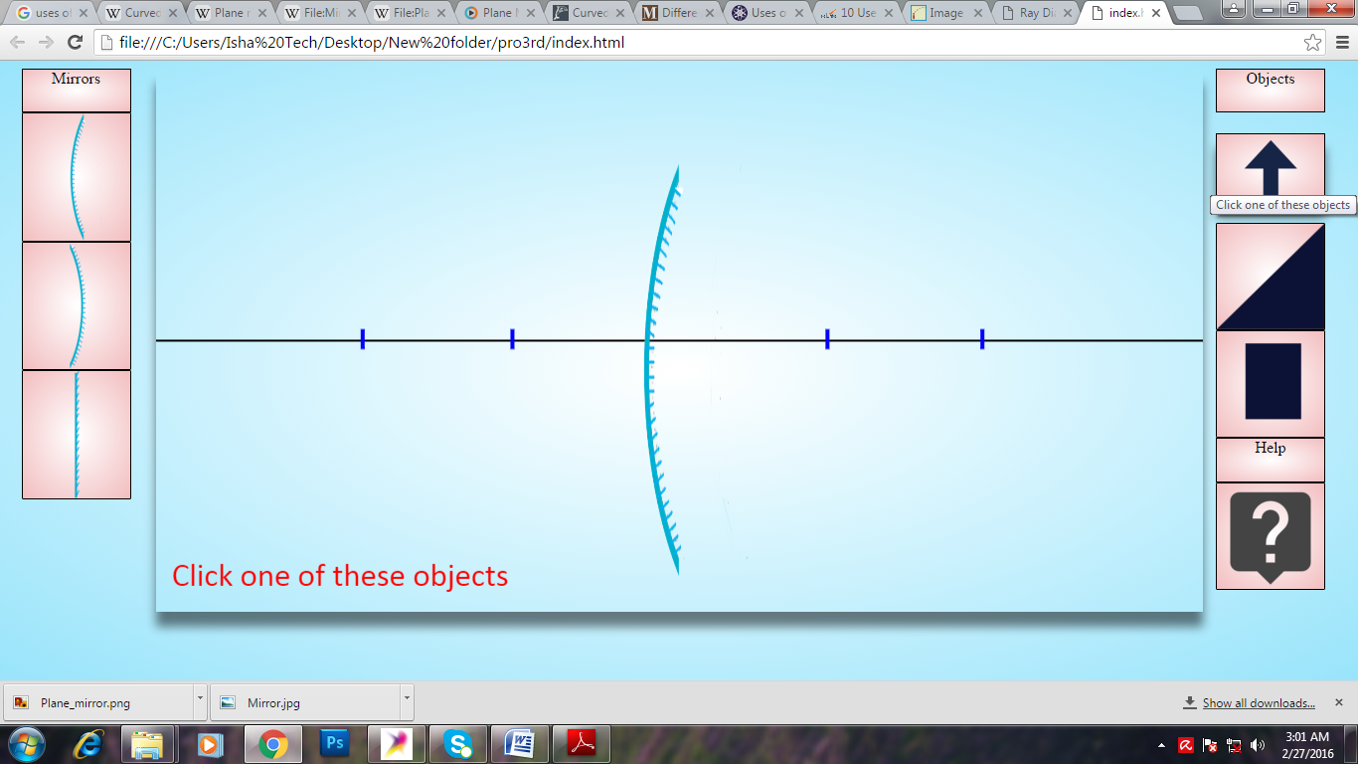

Just click on one of the objects

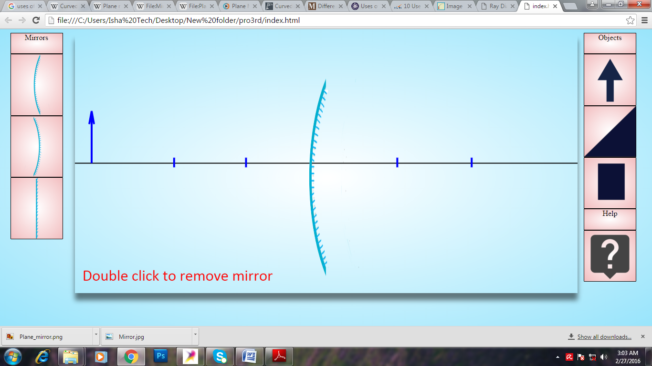

Selected Object will appear in the experimental Area

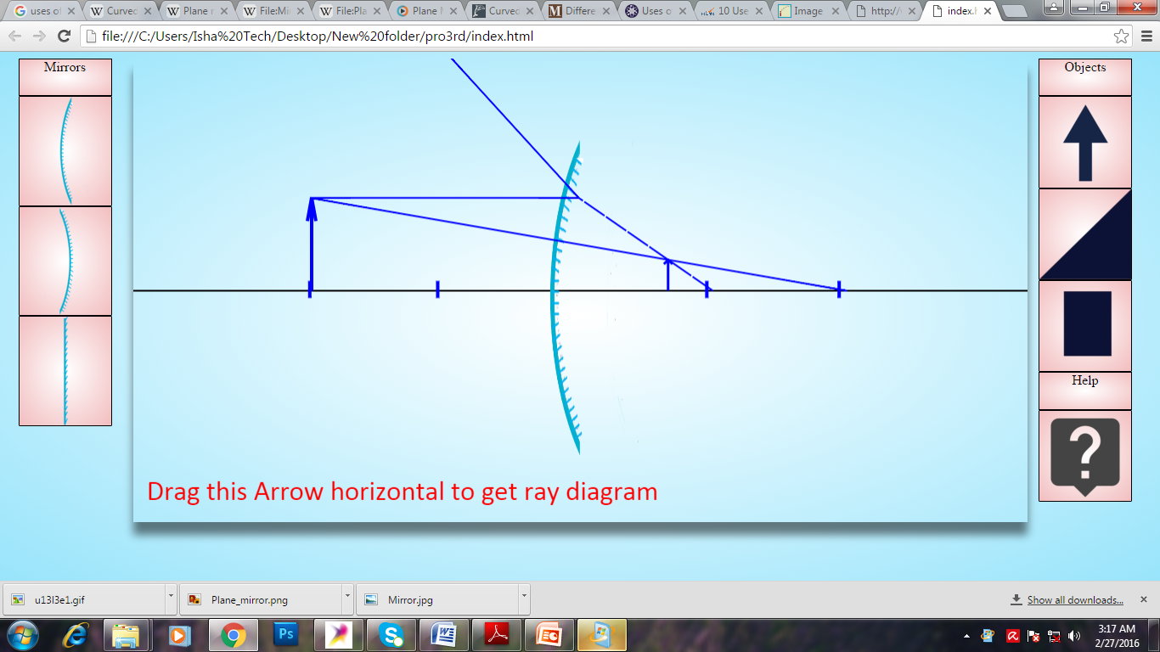

When you Drag the object horizontally the image and ray

Diagram will appear

**5. Future Works**

* Simulation of combine lenses and mirrors
* Include calculation for image distance and magnification